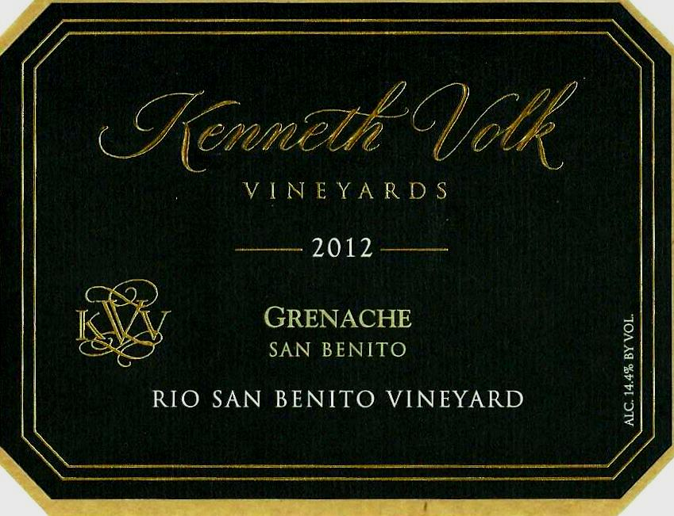
Appellation: Rio San Benito Vineyards
pH: 3.24
Alcohol by volume: 14.4%

T.A.: 0.660g/100mL

R.S.: 0.045%

Malic Acid: 10mg/100mL

Bottling Date: 4/2/2014

Cases Produced: 404

Suggested Retail: $

Produced and Bottled by:
Kenneth Volk Vineyards
5230 Tepusquet Road
Santa Maria, CA 93454
805.938.7896
www.volkwines.com
In The Vineyard
Our 2012 Grenache is a vineyard designate from the Rio San Benito Vineyard of San Benito County. The vineyard is north of the town of Tres Pinos, on a river bench overlooking the San Benito River. Thankfully, 2012 was a more typical growing season (if there is such a thing) than the prior vintages of 2010 and 2011. It was a warm wine growing season, punctuated with some extreme heat spells. This season was the true start of the current extended drought in California with below average rainfall in San Benito County. The soils of the Rio San Benito property are a well-draining mix of gravel, and rounded river rock with calcium carbonate and limestone deposits. The vineyard was originally part of an Almaden Vineyards’ grape trial block, and the clonal selection of Grenache is a mixture. In 2012, the Grenache had the potential for an enormous crop, but warm offshore winds during bloom caused extensive shatter during flowering. The poor set resulted in loose clusters and greatly reduced the cluster weights. The late spring and early summer was warmer than usual. An aberration of the growing season was not necessarily the high day time temperatures as much as the much higher than normal, daily low temperatures. Many morning lows were above 50 degrees which had a tendency to advance vine growth at the expense of acid retention in the juice of the berries. Just before harvest, in late September, an extensive heat wave pushed temperatures above 100 degrees. This temperature spike accelerated sugars and the desiccation of overly exposed clusters.
In The Cellar
The fruit was picked on three separate dates. Multiple harvests were necessary because of the difficulty in getting hand picking crews. The fruit was destemmed without crushing, and meticulously hand sorted for jack stems and raisins prior to fermentation. A combination of open top and closed top fermenters were employed, and a cool fermentation conducted. Basket pressed prior to cap fall, the young wine finished primary and malolactic fermentation in French and Hungarian cooperage. The wine remained on its light fermentation lees throughout its 18 months in barrel adding texture and roundness to the wine’s mouth feel.
In The Glass
Bottled April 2nd, 2014, this wine has had nearly two years of bottle aging before release. The finished wine shows the ripeness of the vintage, with aromas and flavors of over-ripe red and black fruits and nuances of five spice and wet river stone.
www.volkwines.com

